Write a playwright test script to automate drop downs in the below sites.
i. For Single select and Multi select options
https://www.letskodeit.com/practice
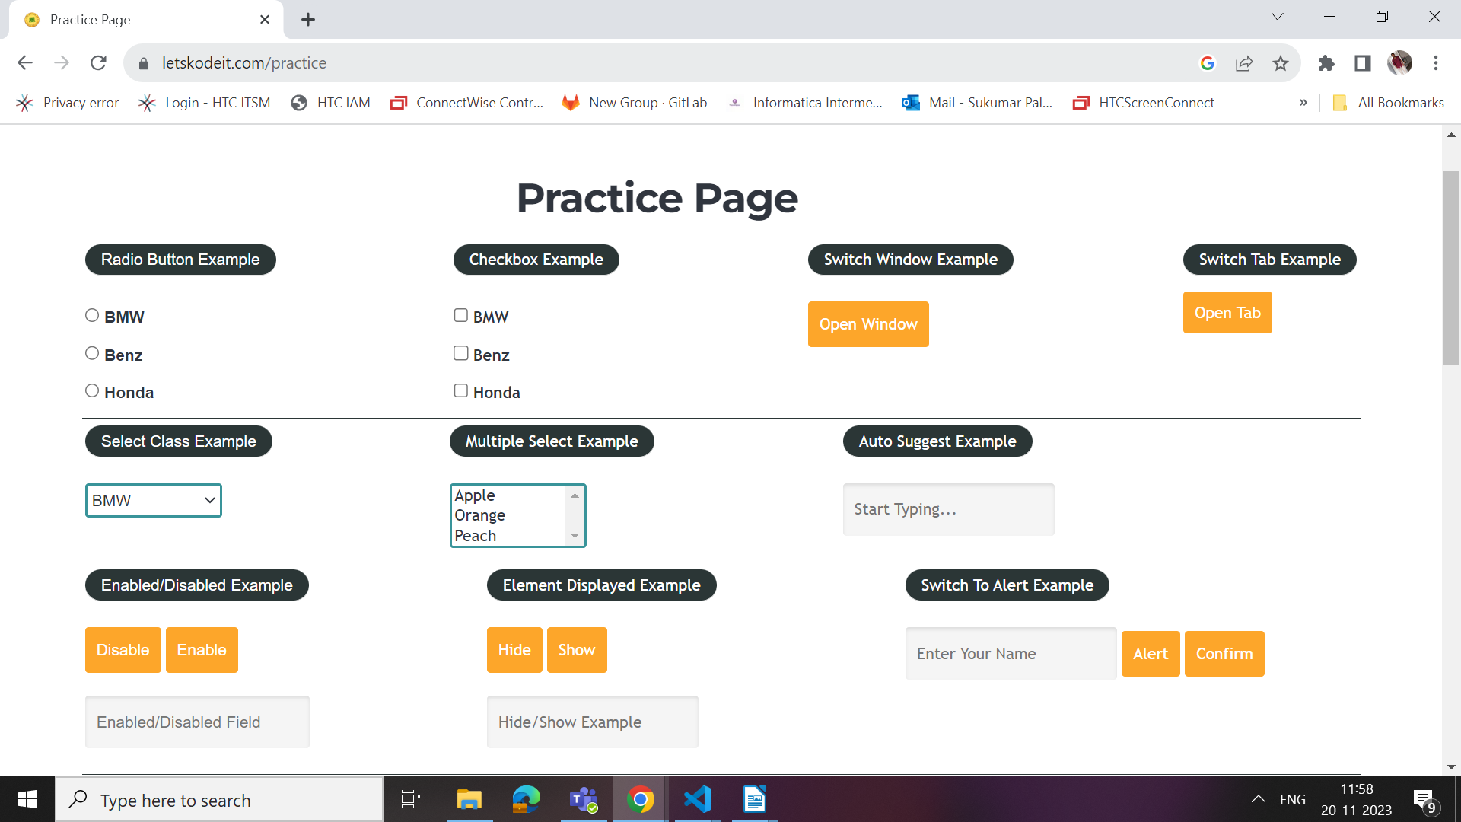

ii. Bootstrap drop down and Auto suggest
https://www.dummyticket.com/dummy-ticket-for-visa-application/

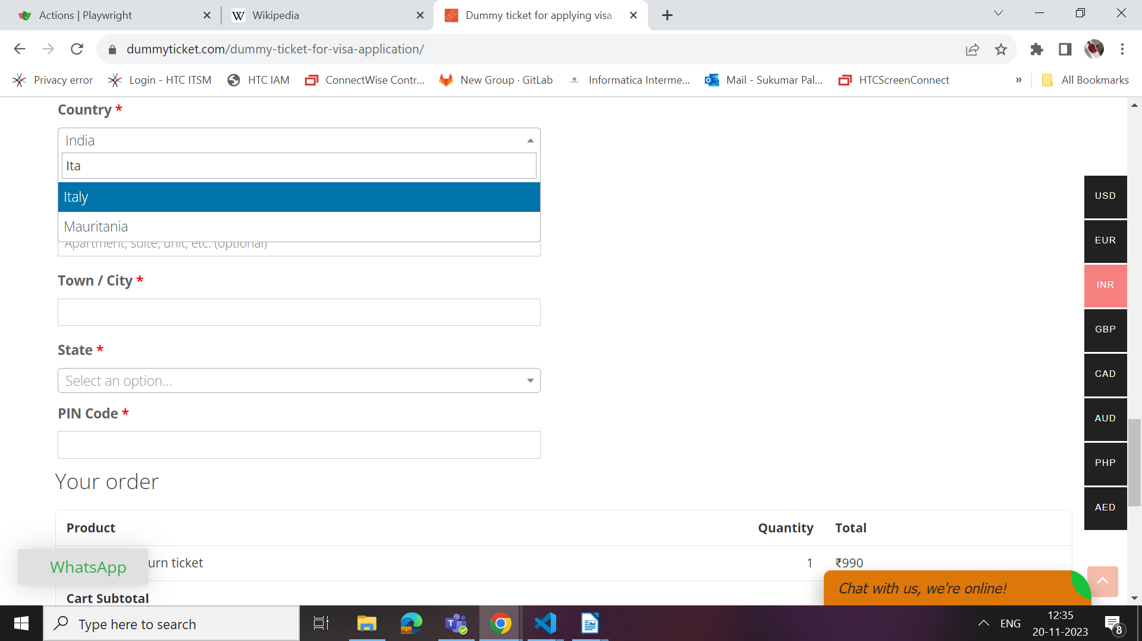

https://www.wikipedia.org/
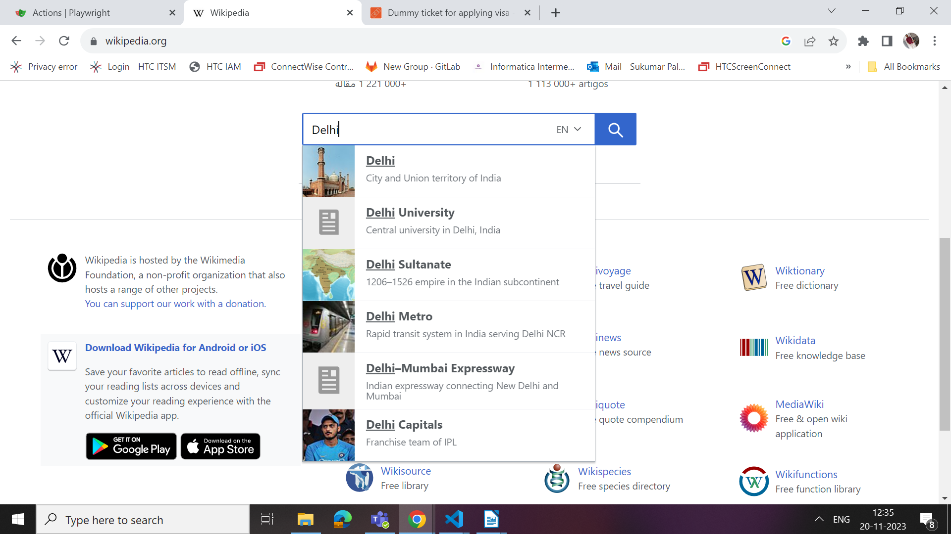

iii. Hidden Drop downs
https://opensource-demo.orangehrmlive.com/web/index.php/admin/viewSystemUsers

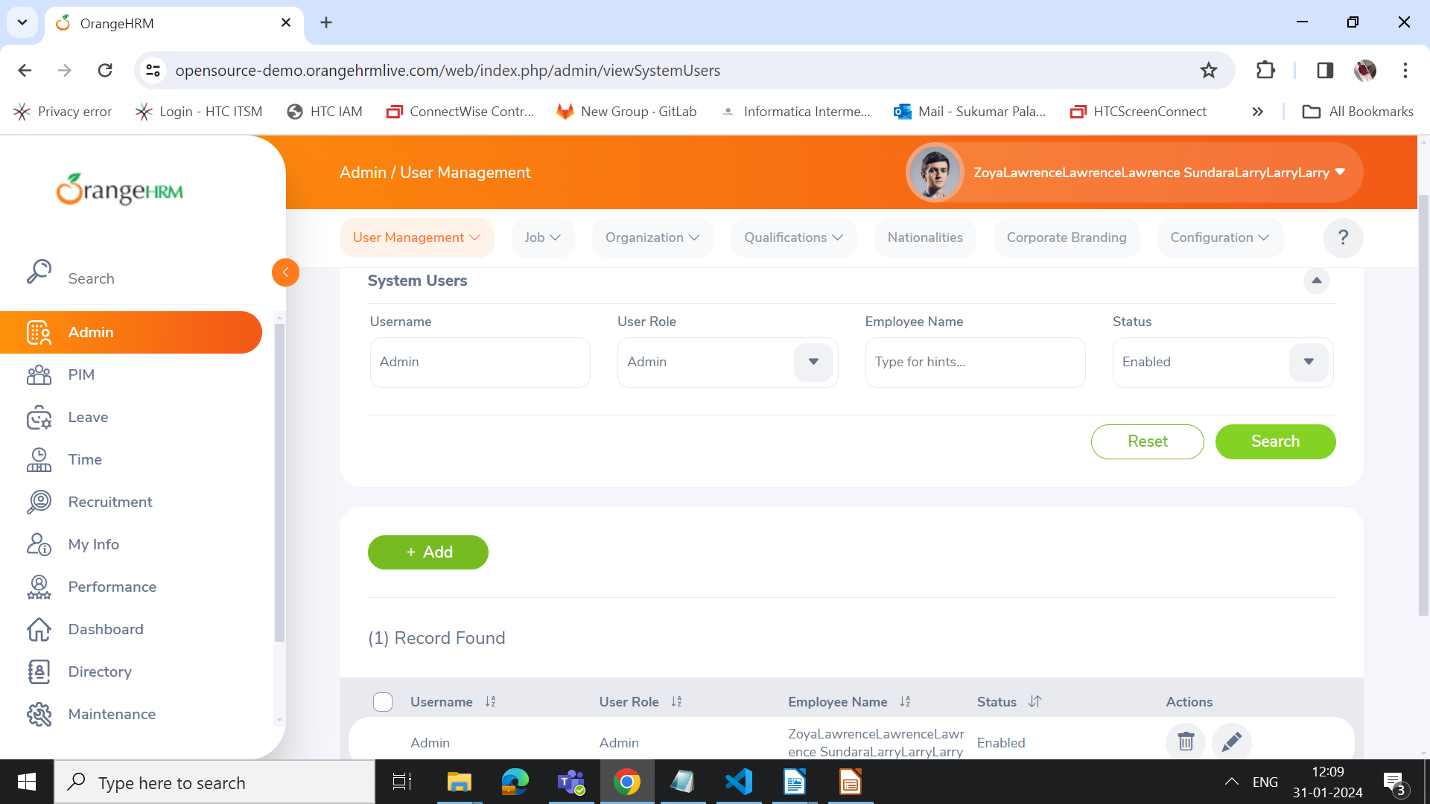

Note: Login to the site with given credentials and Enter into Admin tab and fill in the necessary details and click on search button.

